 Project for CSE471

**Title of the Project:**

**Travel Planning and Tour Guide Finding Portal**

**Group Number:05 Group Members:**

|  |  |
| --- | --- |
| **Student ID** | **Student Name** |
| **18201118** | **Arko Mazhar** |
| **19101116** | **Sumaiya Mehjabeen** |
| **18101575** | **Tasnim Fuyara Chhoan** |

**Sequence Diagram**

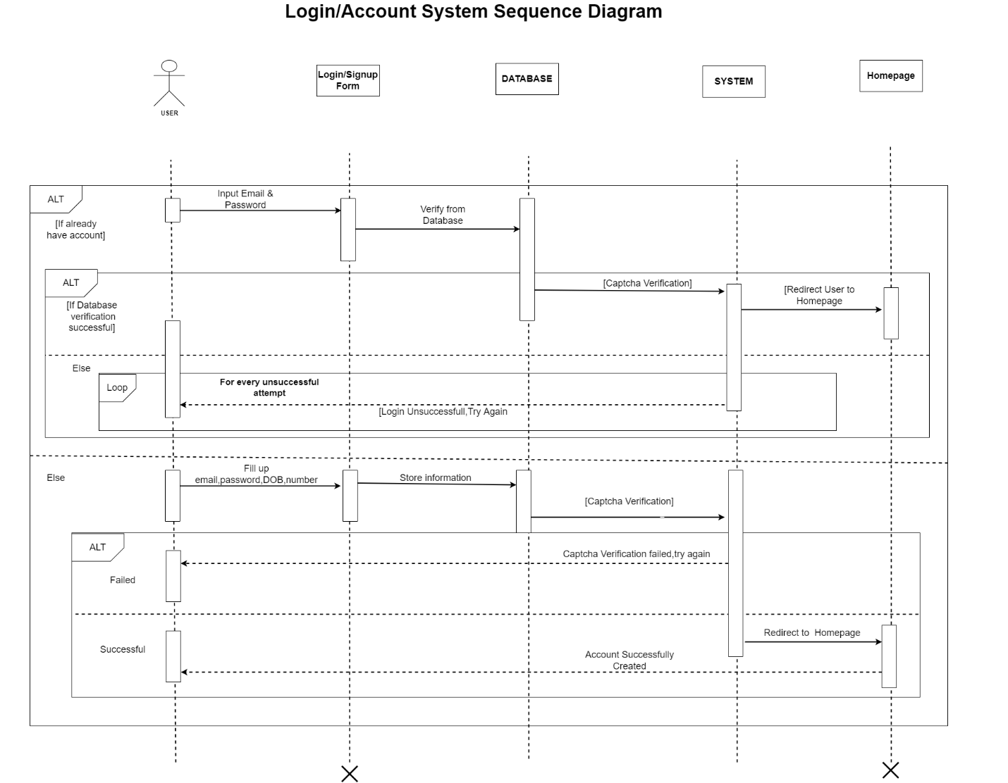

Short Description: Users can do two things, i) login and ii) create account. If they have an account then they can login using their login credentials. For new users, they have to fill up the sign up form and their information will be stored into the database. After that both new and old users have to go through captcha verification. After verification they will be redirected to the home page.

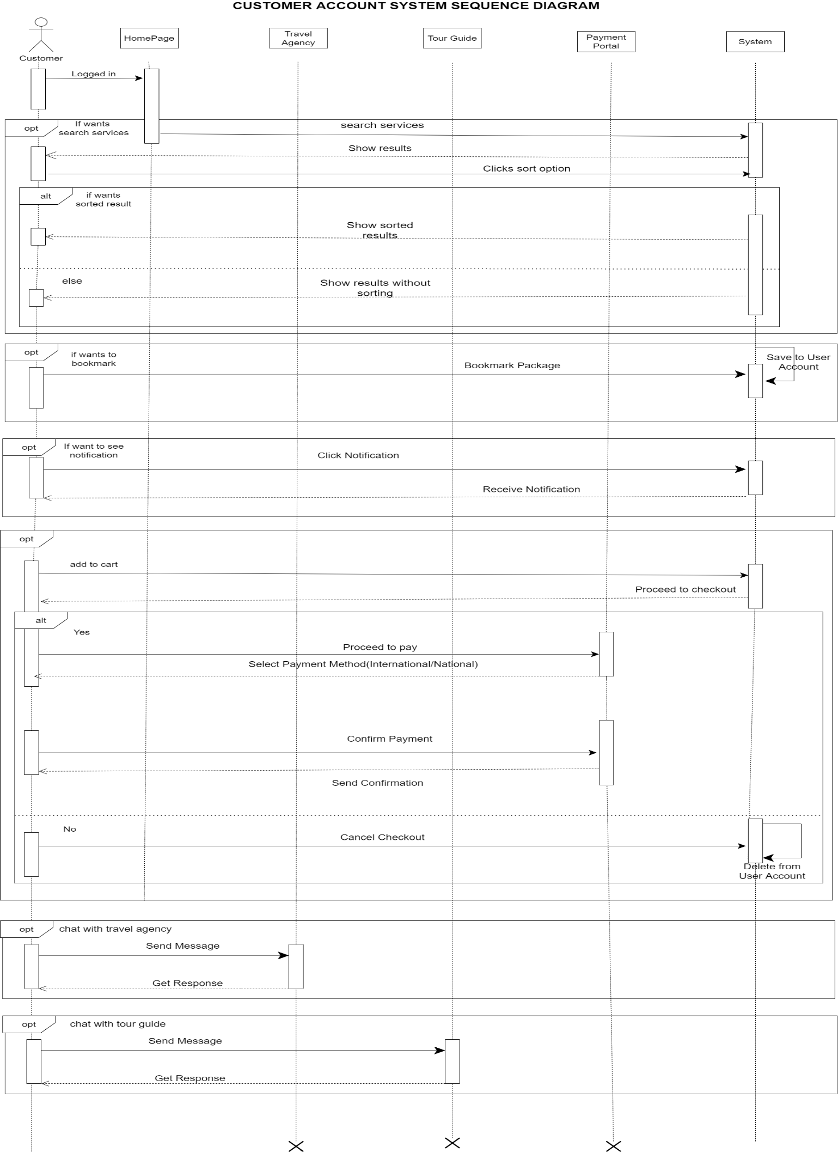

Short Description:

Here, customers can receive notifications,search services, chat and bookmark their

favourite packages. They can sort packages depending on price,date, location and

other criteria. They can also book packages and confirm their payment using

various payment methods. Whenever they add a package, a security device will be

added to their cart free of cost.

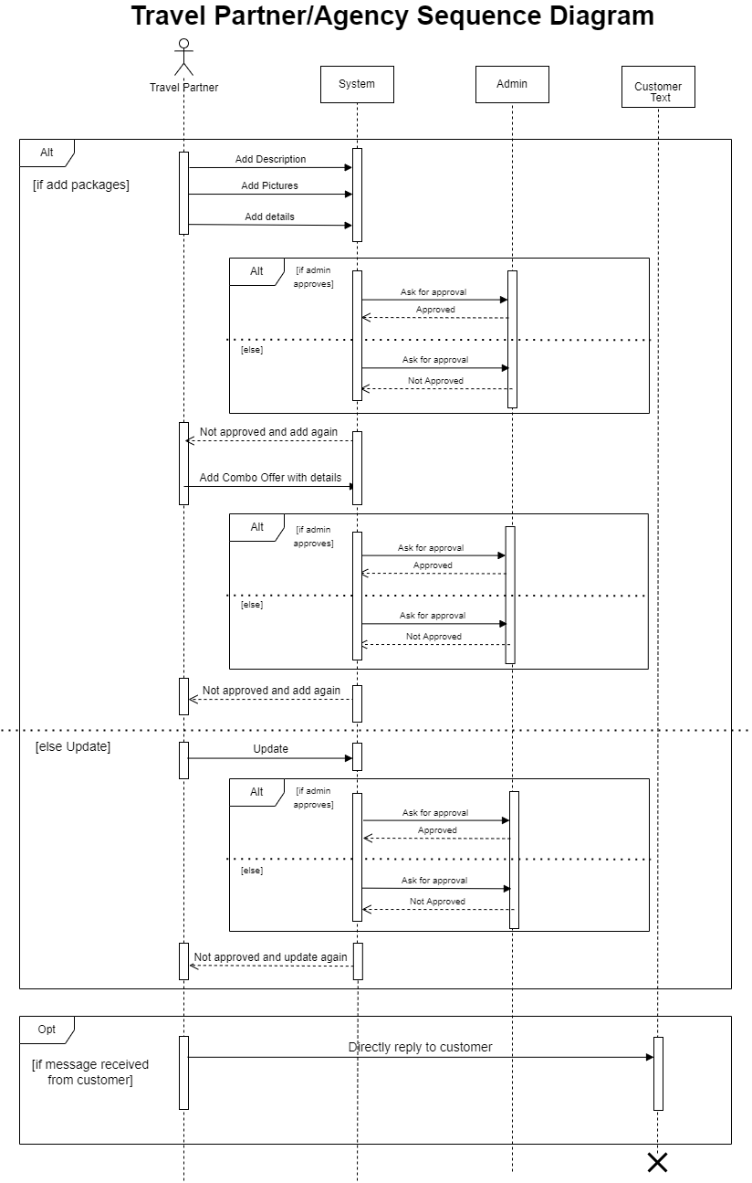

**Short Description:**

The activity diagram "Travel Partner" represents features those travel agencies can access and update towards the system.They can add travel packages in various catagories. Updating any feature to system require admin approval. Here, agencies can also respond to customers, provide suggestions and services.

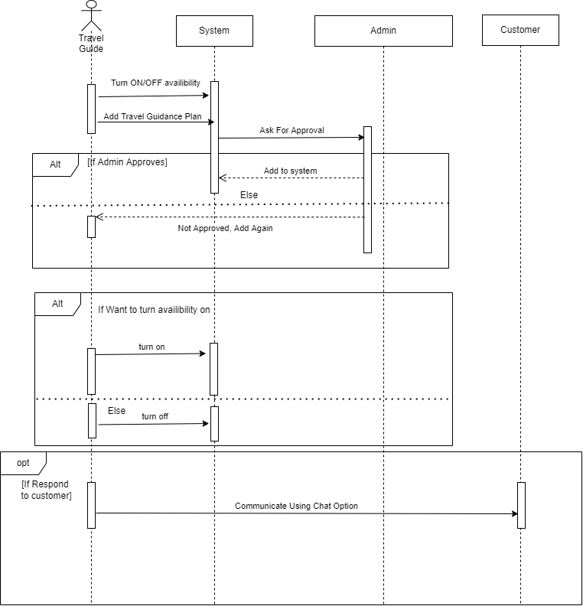

**Short Description:**

The activity diagram "Tour guide" shows the guide facility to the system. Here,

travel guides can add and update all guidance details to the system which require

admin approval. Guides can also set their availability status. Besides, they can

directly interact with customers and provide their services.